**METRIC CONVERSION TABLE**

|  |  |  |  |
| --- | --- | --- | --- |
|  | **Multiply** | **By** | **To Obtain** |
|  | Millimetres | 0.03937 | Inches |
|  | Millimetres | 0.003281 | Feet |
|  | Metres | 3.281 | Feet |
|  | Kilometres | 0.621 | Miles |
| **Linear Measure** |  |  |  |
|  | Inches | 25.4 Exact | Millimetres |
|  | Feet | 304.8 | Millimetres |
|  | Feet | 0.3048 | Metres |
|  | Miles | 1.609 | Kilometres |
|  | Square Millimetres | 0.00155 | Square Inches |
|  | Square Metres | 10.764 | Square Feet |
|  | Square Kilometres | 247.1 | Acres |
|  | Hectares | 2.471 | Acres |
| **Square Measure or** | Square Kilometres | 0.386 | Square Miles |
| **Area** | Square Inches | 645.2 | Square Millimetres |
|  | Square Feet | 0.0929 | Square Metres |
|  | Acres | 0.00405 | Square Kilometres |
|  | Acres | 0.4047 | Hectares |
|  | Square Miles | 2.59 | Square Kilometres |
|  | Millimetres | 0.061 | Cubic Inches |
|  | Litres | 0.22 | Gallons (Can.) |
|  | Cubic Metres | 35.31 | Cubic Feet |
|  | Cubic Metres | 1.308 | Cubic Yards |
| **Volume or Capacity** |  |  |  |
|  | Cubic Inches | 16.39 | Millimetres |
|  | Gallons (Can.) | 4.55 | Litres |
|  | Cubic Feet | 0.0283 | Cubic Metres |
|  | Cubic Yards | 0.765 | Cubic Metres |
|  | Kilograms per | 2.2046 | Pounds, avoirdupois |
|  | Tonnes, metric | 1.102 | Tons, short |
| **Mass** |  |  |  |
|  | Pounds, avoirdupois | 0.4536 | Kilograms per |
|  | Tons, short | 0.907 | Tonnes, metric |
|  | Kilograms per |  | Pounds per |
|  | Cubic Metre | 0.0624 | Cubic Foot |
| **Density** |  |  |  |
|  | Pounds per |  | Kilograms per |
|  | Cubic Foot | 16.019 | Cubic Metre |
| **Force\*** | Kilonewtons | 0.225 | Kips(1000 ponds force) |
| Kips | 4.448 | Kilonewtons |
|  | Kilopascals | 20.89 | Pounds per square foot |
| **Pressure* or** | Megapascals | 0.45 | Kips per square inch |
| **Stress\*** | Pounds per square foot | 0.0479 | Kilopascals |
|  | Kips per square inch | 6.895 | Megapascals |
|  | Degrees, Celsius | multiply by 1.8 | Degrees, Farenheit |
|  |  | then add 32 |  |
| **Temperature** | Degrees, Farenheit | subtract 32 | Degrees, Celsius |
|  |  | then multiply |  |
|  |  | by 0.555 |  |

**Linear Measurement**

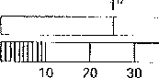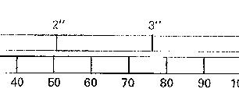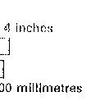

One millimetre (1 mm) is equal to a thousandth part of a metre (0.001 m) and is a little greater than 1/32”.

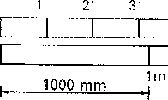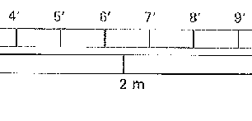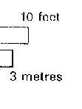

One metre (1 m) is equal to a thousand millimetres (1000 mm) and is approximately 3 ft. 3 inches.

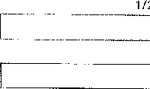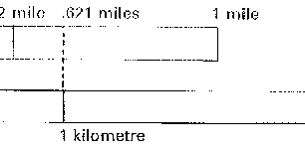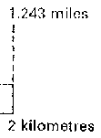

A kilometre is slightly less than five-eighths of a mile.

**Square measure** (Area)

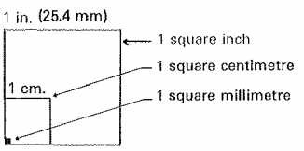The square millimetre is a very small unit approximately 1/645 of a square inch.

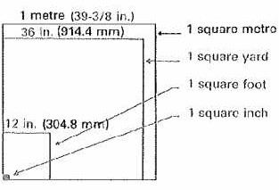

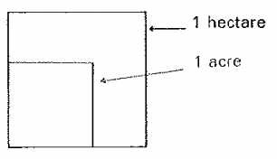A hectare is 10000 m2, and is approximately equal to 2-1/2 acres. 100 hectares make up one square kilometre which is about 4/10 of a square mile.

**Cubic measure** (Volume)

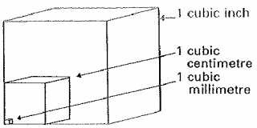The cubic centimetre is approximately 1/16 of a cubic inch making its application limited to very small measurements.

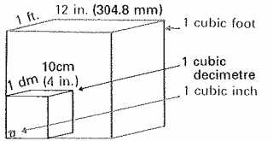A cubic decimetre is 1000 cm3, equivalent to the volume of a 10 cm (approx. 4”) cube.

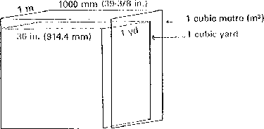

In the metric system, cubic measure units are directly related to the units of measure for capacity. Volume applies to solids; capacity applies to fluids and gases.

**Liquid measure** (Capacity)

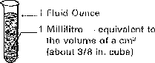

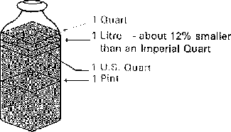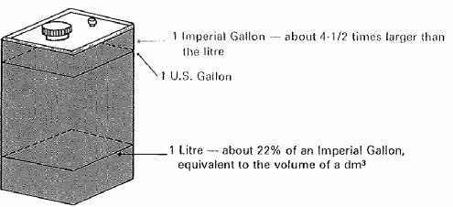

**Mass** (weight) **and Density**

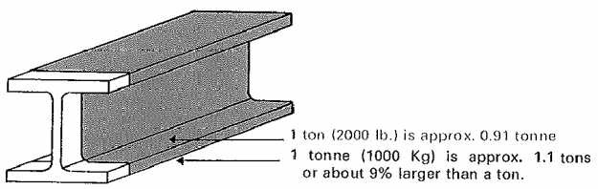

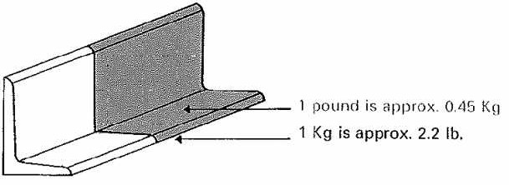

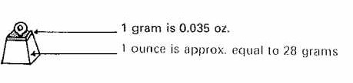

**Relationship between liquid, cubic and mass units of metric measurement**

The metric system of measurement provides one very distinctive benefit in that the units for liquid measure, cubic measure and mass (or weight) are interrelated. In theory, 1 litre (/) of water has a volume of 1 cubic decimetre (dm3) and weighs 1 Kilogram (Kg). In practice these quantities will vary slightly due to the influence of temperature.

Liquid measure

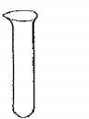

1 millilitre (ml)

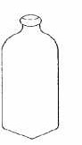

1 litre (*l*)

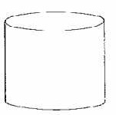

1 Kilolitre

Cubic measure

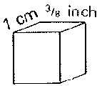

1 cubic centimetre (cm3)

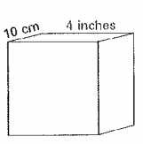

1 cubic decimetre (dm3)

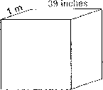

1 cubic metre (m3)

Mass (weight) of water

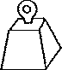

1 gram (g)

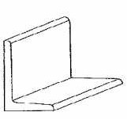

1 Kilogram (Kg)

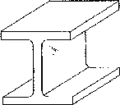

1 tone (t)

# Force, Pressure and Stress

NEWTON

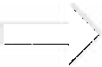

(approx. ¼ the pound-force)

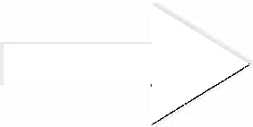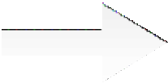

(approx. 4-1/2 times the Newton)

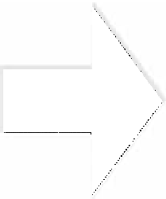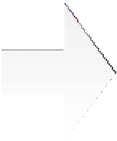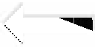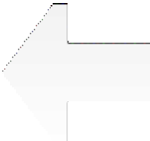

Pound-Force Pressure per

sq. inch

Pound-Force Stress per sq.

inch

Kilopascal Pressure

The unit of force is the Newton (N) which is defined as the force that:

When applied to a mass of one Kilogram, gives it an acceleration of one metre per second p er second ( m/s2). The standard acceleration under the force of gravity is approximately 9.8 m/s2.

Therefore, a mass of one Kilogram, acted on by gravity, is said to exert a force of

9.8 N on its support.

The unit of pressure or stress is the Pascal (Pa) and is defined as the pressure or stress produced when a force of one Newton is applied to an area of one square metre. Thus, N/m2 = Pa and N/mm2 = MPa (the unit most used for stress in steel construction.

Kilopascal Stress

**Conversion Factors:**

Force units

1 pound-force per foot

1 Kip-force (1,000 pf) 4,448.222 Newtons (N) 4.448,222 Kilonewtons (KN) Pressure/Stress units

1 pound-force per square inch 6,894.757 Pascals (Pa)

6.894,757 Kilopascals (KPa)

0.006,894,757 Megapascals (MPa) 1 pound-force per square foot 47.880,26 Pascals (Pa)

0.047,880,26 Kilopascals (KPa)

0.000,047,880,26 Megapascals (MPa)

Fore units

1 Newton 0.224,809 pound-force 0.000,224,808,92 Kip-force

1 Kilonewtons 224.809 pound-force 0.224,809,92 Kip-force

1 Meganewton 224,809 pound-force 224.808,92 Kip-force Pressure Stress units

1 Pascal 0.000,145,038 pound-force per sq. in. 0.020.885,4 pound-force per sq. ft.

1 Kilopascal 0.145,038 pound-force per sq. in. 20.885,4 pound-force per sq. ft.

1 Megapascal 145.038 pound-force per sq. in. 20,885.4 pound-force per sq. ft.

# Temperature

Nine degrees Fahrenheit is equivalent to five degrees Celsius.

Therefore:

Temperature in Fahrenheit - 32 9

Temperature in Celsius

=

5

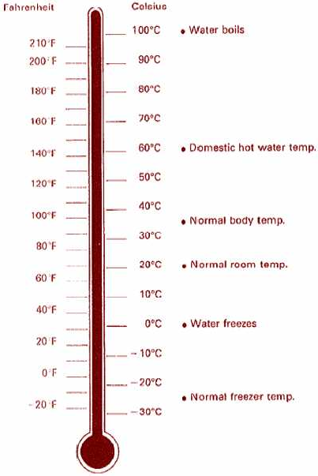To obtain degrees Celsius – subtract 32 from ⁰F then multiply by 0.555 To obtain degrees Fahrenheit – multiply ⁰C by 1.8 then add 32.